**JAVA LMS LAB-2:**

**Write a program that prompts the user to enter an integer. Handle the**

**InputMismatchException that might occur if the user enters a non-integer value.**

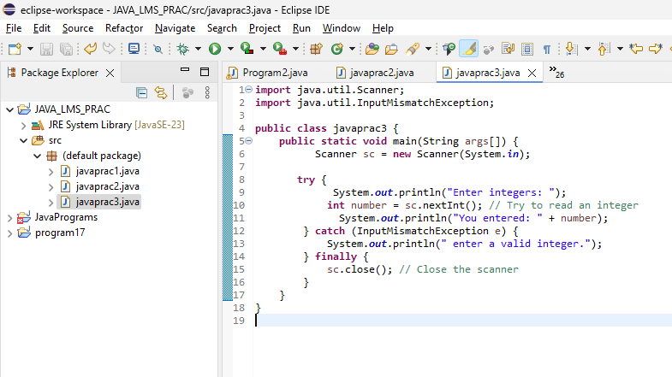

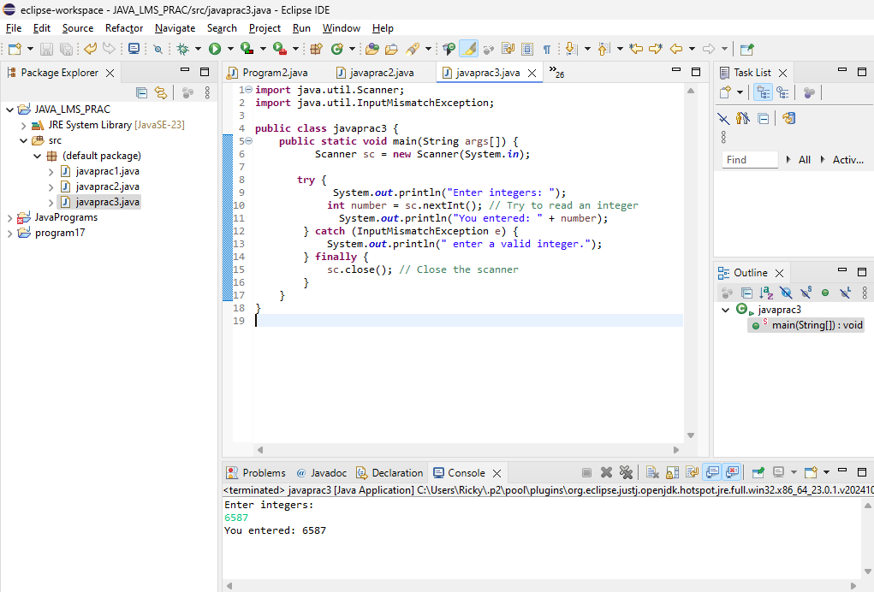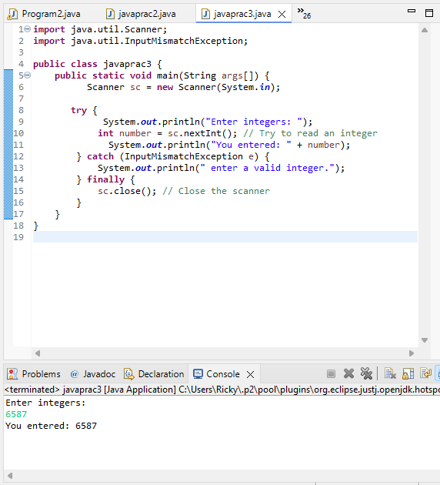

**import** java.util.Scanner;

**import** java.util.InputMismatchException;

**public** **class** javaprac3 {

**public** **static** **void** main(String args[]) {

Scanner sc = **new** Scanner(System.***in***);

**try** {

System.***out***.println("Enter integers: ");

**int** number = sc.nextInt(); // Try to read an integer

System.***out***.println("You entered: " + number);

} **catch** (InputMismatchException e) {

System.***out***.println(" enter a valid integer.");

} **finally** {

sc.close(); // Close the scanner

}

}

}

**Write a program that takes user input and converts it to an integer using**

**Integer.parseInt(). Handle the NumberFormatException and NullPointerException**

**that might occur during**the**conversion.**

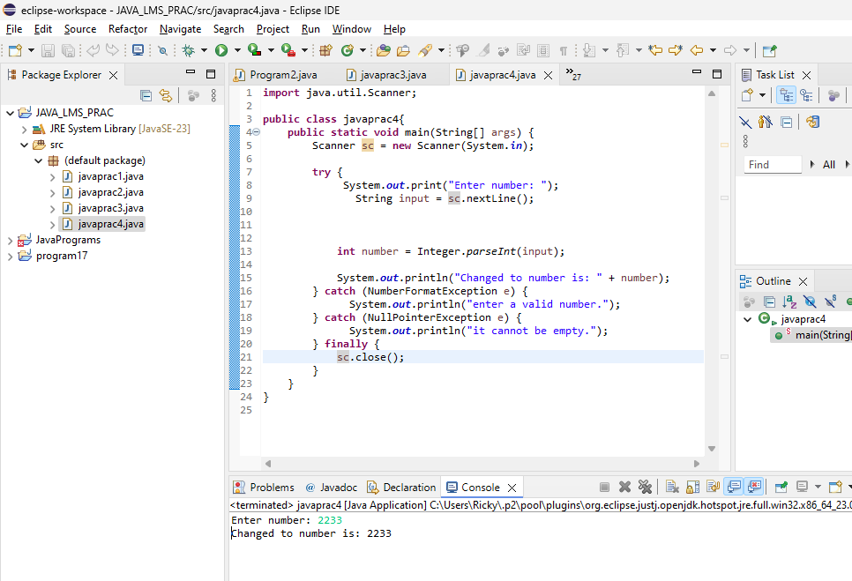

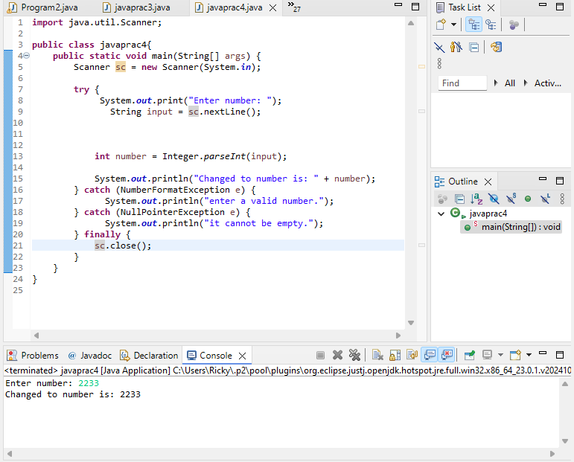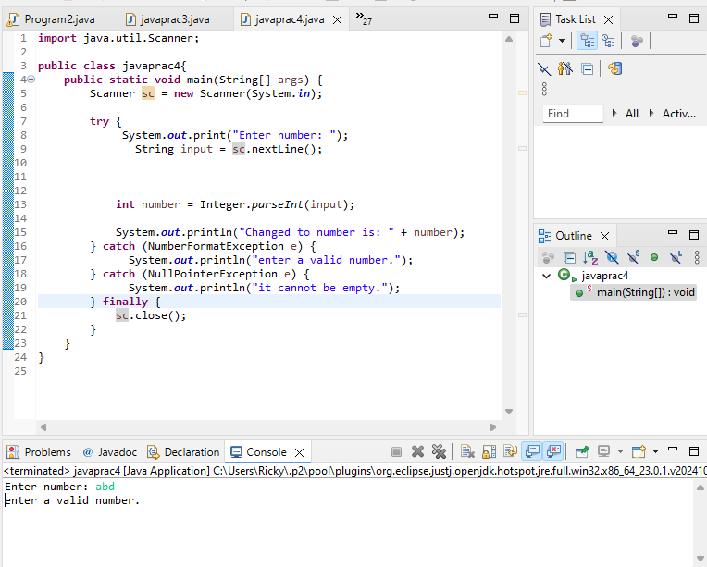

**import** java.util.Scanner;

**public** **class** javaprac4{

**public** **static** **void** main(String[] args) {

Scanner sc = **new** Scanner(System.***in***);

**try** {

System.***out***.print("Enter number: ");

String input = sc.nextLine();

**int** number = Integer.*parseInt*(input);

System.***out***.println("Changed to number is: " + number);

} **catch** (NumberFormatException e) {

System.***out***.println("enter a valid number.");

} **catch** (NullPointerException e) {

System.***out***.println("it cannot be empty.");

} **finally** {

sc.close();

}

}

}